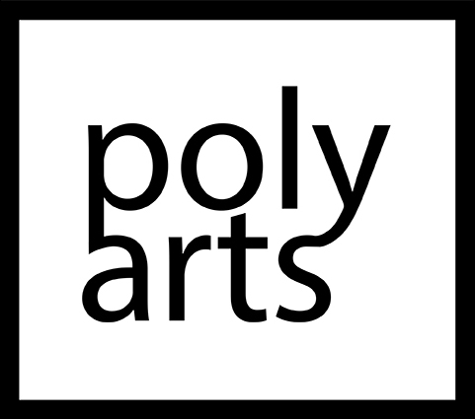

Stewart Copeland
Composer/Drums
Stewart Copeland has spent more than three decades at the forefront of contemporary music as rock star and acclaimed film composer, as well as in the disparate worlds of opera, ballet, and world and chamber music.
Recruiting Sting and Andy Summers in 1977, Copeland is renowned as the founder of The Police, a band that became a defining force in rock music from the ‘80s through to the present day. His career includes the sale of more than 60 million records worldwide, and numerous awards, including seven Grammy awards.
Copeland moved beyond the rock arena in the mid-1980s when he returned to his classical roots with creative pursuits in concert and film music. His concert works include BEN-HUR, A Tale of the Christ, which features Copeland as soloist in a live orchestral score for the 1925 silent film; Tyrant’s Crush: Concerto for Trapset and Orchestra commissioned by Pittsburgh Symphony Orchestra, Poltroons in Paradise commissioned by the Royal Liverpool Philharmonic Orchestra; and Gamelan D’Drum, commissioned by the Dallas Symphony Orchestra for the world percussion group D’Drum.
In 2017, The Chicago Opera Theatre premiered Copeland’s surreal chamber opera The Invention of Morel, a co-commission with Long Beach Opera based on the novel by Adolfo Bioy Casares. Copeland has also written two operas based on stories by Edgar Allen Poe: The Cask of Amontillado and The Tell-Tale Heart.
Copeland continues to pursue his love for Opera and 2020 saw the premiere of Electric Saint, commissioned by Weimar DNT as well as his Oratorio, Satan’s Fall, based on John Milton’s Paradise Lost, which premiered in Pittsburgh in February 2020 and was performed across the US in 2021, with the UK and many more European performances still to come.
In 2021, Copeland created a new project, Stewart Copeland: The Police Deranged for Orchestra, which focuses on the epic rise of his career. The concert is an evening bursting with The Police’s biggest hits including Roxanne, Don’t Stand To Close To Me and Message in a Bottle arranged for full symphony orchestra as well as hand-picked highlights from Copeland’s compositions. The project has toured across Northern America and Europe throughout 2021 – 2022 with many sold-out concerts and will continue touring in to 2023/24 in a new format.

He is also working on a Raga/ Indian project with the Soweto Gospel Choir and Anoushka Shankar in this same spirit.
In 2022, his rock opera The Witches Seed was premiered in Italy at the Tones on the Stones Festival in a stunning Quarry, in collaboration with Creative Partner Chrissie Hynde and with a libretto by regular collaborator Jonathan Moore, many more replicas in progress for 23/24/25.
Recipient of the Hollywood Film Festival’s first Outstanding Music in Film Visionary Award, Double Grammy winner for his Divine Tides album, inductee to the Rock and Roll Hall of Fame, Copeland has been responsible for some of the film world’s most innovative and ground breaking scores. His numerous film scores include Oliver Stone’s Wall Street, the seminal score for the Golden Globe-nominated soundtrack for Francis Ford Coppola’s Rumble Fish, the score for Bruno Barreto’s Oscar-nominated Four Days in September and his Emmy nomination for the Showtime pilot and series Dead Like Me. His work in television includes contributions to The Equalizer, Babylon V, and Desperate Housewives and he also scored the blockbuster hit video game Spyro.

